An Efficient and Smart Parking System Using Arduino Uno

Revati Tushar Aute

101153, ENTC

Vishwakarma Institute of Information Technology (VIIT)

Pune, India

revati.22311517@viit.ac.in

Atharva Rajendra Joshi

101149, ENTC

Vishwakarma Institute of Information Technology (VIIT)

Pune, India

atharva.22311496@viit.ac.in

Tanushri Chetan Rajput

101145, ENTC

Vishwakarma Institute of Information Technology (VIIT)

Pune, India

tanushri.22311251@viit.ac.in

Manas Girish Kulkarni

101158, ENTC

Vishwakarma Institute of Information Technology (VIIT)

Pune, India

manas.22311608@viit.ac.in

*Abstract*—The Smart Parking System is a cutting-edge project in basic electronics aimed at efficiently managing parking spaces. It utilizes sensors to detect empty parking slots and communicates their availability through an LCD screen using I2C communication. This system revolutionizes parking resource utilization, reducing congestion, and improving user convenience. Its straightforward yet impactful design showcases how electronics can solve everyday challenges like parking management.

The system components include an Arduino UNO, an ultrasonic sensor, a servo motor, a 16x2 LCD I2C display, and jumper wires. The ultrasonic sensor plays a crucial role by accurately measuring distances, helping determine whether a parking spot is occupied or vacant. This information is then relayed to a central system, enabling drivers to easily locate available parking spaces without the inconvenience of manual searching. Moreover, it assists parking lot operators in efficiently managing their spaces by providing real-time occupancy data.

In this report, we delve into the functionality, benefits, and significance of the Smart Parking System, highlighting its practical application of electronics to tackle common parking management issues.

# Introduction

The Smart Parking System is an innovative project in aimed at efficiently managing parking spaces using ultrasonic sensors, an Arduino microcontroller, an LCD display with I2C communication, and other essential components. The system detects vacant parking slots using ultrasonic sensors and displays their availability on an LCD screen, facilitating easy identification of open spots without manual searching.

This project's key components include ultrasonic sensors (HC-SR04) for vehicle detection, an Arduino microcontroller to control system operations and manage data, an LCD display with an I2C module to show real-time parking slot availability, and connecting wires for electrical connections. The I2C communication protocol enables seamless data transfer between the microcontroller and the LCD display.

Atharva Vishwas Deshpande

101161, ENTC

Vishwakarma Institute of Information Technology (VIIT)

Pune, India

atharva.22311679@viit.ac.in

The system's functionality is based on ultrasonic sensors measuring the distance between the sensor and objects, determining parking spot occupancy. This information is then relayed to a central system, aiding drivers in finding available parking spots conveniently. Moreover, it assists parking lot operators by providing real-time occupancy data for effective space management.

Overall, this Smart Parking System showcases the practical application of electronics in addressing parking management challenges, optimizing resource utilization, reducing congestion, and enhancing user convenience.

# OBJECTIVES

## Optimize Parking

First, confirm that you have the correct template for your paper size. This template has been tailored for output on the A4 paper size. If you are using US letter-sized paper, please close this file and download the Microsoft Word, Letter file.

## Instant Updates

Make sure the system always shows the latest parking information on the LCD screen, helping drivers quickly find open spots through I2C. This feature empowers drivers with instant insights into vacant spots, facilitating seamless parking experiences.

## Easy to Use

Design a clear and simple display on the screen so anyone can see where parking is available. By presenting parking availability in a straightforward manner, the system becomes accessible to all users, irrespective of their technical proficiency.

## Prevent Mistakes

Build the system to avoid false readings, keeping it accurate and reliable for smooth parking experiences. This proactive approach guarantees the system's reliability, providing consistently accurate parking status updates and fostering smooth parking operations.

# LITERATURE SURVEY

This project presents an innovative approach to automate car parking systems utilizing Arduino microcontroller technology, ultrasonic sensors, LCD display, and servo motor. Traditional parking systems often suffer from inefficiencies, lack of real-time information, and manual operation, leading to congestion and inconvenience. Our proposed system aims to revolutionize parking infrastructure by integrating advanced technologies for enhanced automation and user experience.

The system employs ultrasonic sensors to detect the presence of vehicles within parking spaces. These sensors are strategically positioned to cover each parking spot, ensuring accurate detection of vehicle occupancy. Upon detecting a vehicle entering or leaving a parking space, the sensor transmits signals to the Arduino microcontroller for processing.

The Arduino microcontroller analyses the sensor data and controls the servo motor mechanism responsible for managing the movement of the parking barrier. This mechanism enables seamless access control to the parking spaces, allowing vehicles to enter or exit as needed.

Additionally, the system features an LCD display that provides users with real-time information, including the availability of parking spaces, instructions for parking, and status updates. This enhances user convenience and improves the overall parking experience.

Furthermore, the Arduino microcontroller is integrated with a server motor, facilitating remote monitoring and control capabilities. Users, such as parking administrators or facility managers, can access the system remotely through a web interface or mobile application. This enables efficient management of parking spaces and enhances operational flexibility.

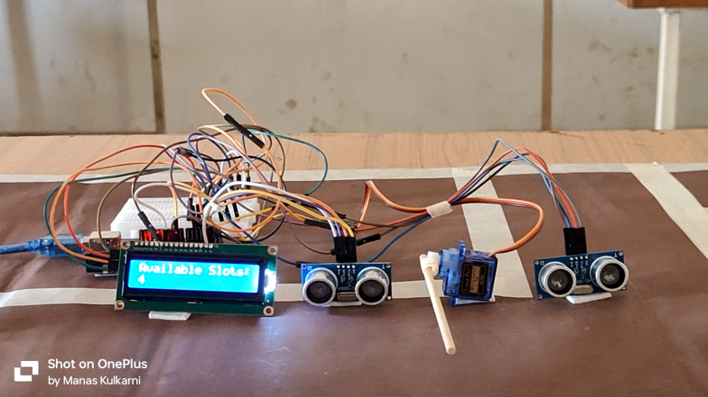

The system incorporates ultrasonic sensors strategically placed to detect the presence of vehicles within parking spaces accurately. These sensors enable real-time monitoring of parking availability, optimizing space utilization and reducing congestion. Data from the sensors are processed by the Arduino microcontroller, which controls the servo motor mechanism responsible for managing parking barriers or gates.

Furthermore, the system features an LCD display providing users with pertinent information such as available parking spaces, directions, and status updates. This real-time feedback enhances user convenience and streamlines the parking process.

Overall, our innovative automation project for a car parking system represents a significant advancement in parking infrastructure, offering improved efficiency, enhanced user experience, and remote monitoring capabilities. By leveraging Arduino technology, ultrasonic sensors, LCD display, and servo motor, this system sets a new standard for modern parking solutions.

***Advantages of our Project:***

* Improved Efficiency: Real-time monitoring of parking spaces optimizes utilization, reducing congestion and wait times.
* Enhanced User Experience: LCD display provides clear instructions and status updates, improving the overall parking experience.
* Remote Monitoring and Control: Integration with a server motor allows for remote access and management, enabling efficient operations.
* Scalability: The modular design of the system allows for easy expansion and integration with existing infrastructure.
* Cost-effectiveness: Automation reduces the need for manual intervention, leading to long-term cost savings.

# Project Layout

The Smart Parking System is a cutting-edge project aimed at revolutionizing parking management using advanced technology. Imagine arriving at a bustling shopping mall or a busy city center, only to find parking spaces are hard to come by, leading to frustration and delays. This system addresses such challenges by employing ultrasonic sensors, an Arduino microcontroller, an LCD display with I2C communication, and other essential components to efficiently manage parking spaces.

At the core of this system's functionality are ultrasonic sensors strategically positioned at the entrances of parking spaces. These sensors work much like the way bats navigate in the dark: they emit ultrasonic waves and measure the time it takes for the waves to bounce back after hitting an object, in this case, a vehicle. The Arduino microcontroller acts as the brain of the system, receiving data from these sensors and making decisions based on predefined criteria. Think of it as a traffic controller directing cars to available spots based on real-time information. Once a spot's availability is determined, the LCD display, connected through I2C communication, updates instantly, providing drivers with a clear visual of where they can park, similar to how weather apps update us on changing conditions.

The LCD display plays a crucial role as the system's user interface, ensuring a seamless experience for drivers. Imagine looking at the screen and seeing a virtual map of the parking lot, color-coded to indicate available and occupied spots. Green dots signify open spaces, while red dots denote spots that are taken. This intuitive interface eliminates the need for drivers to circle around in search of parking, akin to how navigation apps guide us with turn-by-turn directions.

One of the system's standout features is its ability to automate barrier control. Upon detecting an open spot, the system sends a signal to a servo motor, which operates much like an automatic gate opener. The barrier smoothly lifts, allowing the vehicle to enter the parking space hassle-free. Conversely, if the spot is occupied, the barrier remains closed, preventing unauthorized access. This automated process mimics the efficiency of toll booths on highways, ensuring a smooth flow of vehicles and orderly parking.

Behind the scenes, the system continuously collects and manages data on parking space occupancy. This data is akin to a treasure trove for parking lot operators, providing insights into usage patterns and trends. Just as online stores use real-time inventory data to restock shelves efficiently, parking operators can optimize space allocation, identify peak hours, and make informed decisions to reduce congestion and enhance the overall parking experience.

This Smart Parking System offers a host of benefits, ranging from reducing traffic congestion and streamlining parking processes to enhancing user convenience and maximizing resource utilization. Looking ahead, the system's future iterations could integrate with mobile apps, allowing users to reserve spots and make payments seamlessly. It could also tap into IoT technology for remote monitoring and dynamic pricing strategies based on demand, aligning with the broader vision of creating smarter, more liveable cities where technology enhances daily experiences for everyone.

.

# Circuit Diagram

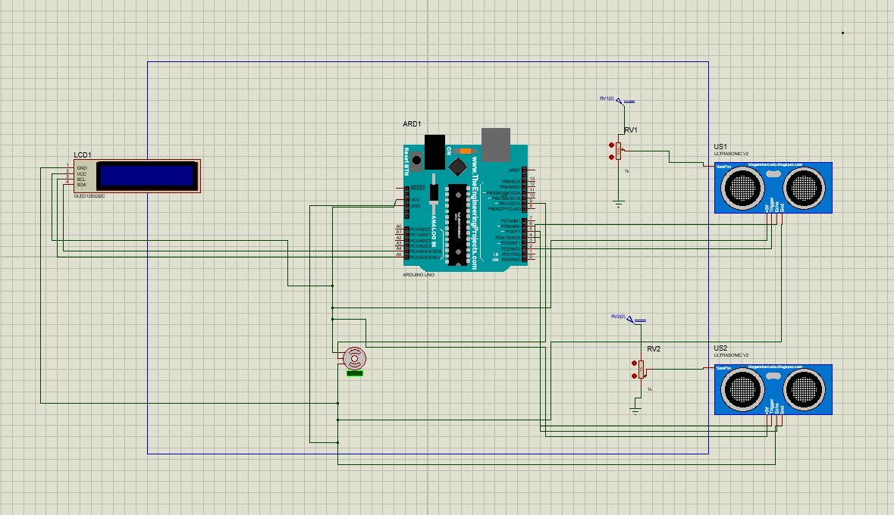

# Components

## *Ultrasonic Sensors (HC-SR04):*

## Detect vehicles in parking slots using ultrasonic waves, measuring bounce-back time to determine occupancy. Data processed by microcontroller for parking availability updates.

## Microcontroller (Arduino):

Controls system operation, processes sensor data, manages LCD display communication via I2C, and makes decisions based on parking slot status.

## LCD Display (with I2C module):

Provides real-time parking availability info visually, facilitating easy spot location for drivers. I2C protocol ensures accurate data transfer between microcontroller and display.

## I2C Communication Protocol:

Enables efficient communication between microcontroller and LCD display, ensuring timely and accurate parking availability updates.

## Power Supply:

Provides necessary electrical power to all system components, ensuring stable and reliable functionality.

## Resistors:

Used for circuit protection, signal conditioning, and stability, regulating current flow and protecting components.

## Connecting Wires:

Essential for interconnecting system components and establishing electrical connections, facilitating signal, power, and data transmission.

These components collectively optimize parking resource utilization, reduce congestion, and enhance user convenience in parking management.

# Working

## STEP 1 : Vehicle Detection

Ultrasonic sensors (HC-SR04) are strategically placed at the entrance of each parking space.

When a vehicle enters, the ultrasonic sensor detects its presence by measuring the distance between the sensor and the vehicle.

## STEP 2 : Sensor Data Processing

The Arduino microcontroller receives data from the ultrasonic sensors. It processes this data to determine whether the parking space is vacant or occupied based on predefined thresholds.

## STEP 3 : LCD Display Update

An LCD display with an I2C module is connected to the Arduino. The Arduino updates the LCD display in real time to indicate the availability of parking spaces. The display shows which parking spots are vacant and which are occupied, providing drivers with easy-to-read information.

## STEP 5 : Barrier Control

If the Arduino determines that a parking space is vacant, it sends a signal to a servo motor. The servo motor then opens the barrier, allowing the vehicle to enter the parking space. If the space is occupied, the barrier remains closed, preventing entry.

## STEP 6 : User Interface

The LCD display serves as the user interface, providing real-time information to drivers. It displays the number of available parking spaces and guides drivers to empty spots, enhancing convenience and reducing search time.

## STEP 7 : Data Management

The system continuously updates and manages parking space occupancy data. This data can be used for analytics, monitoring parking lot usage, and optimizing space allocation.

Overall, the Smart Parking System combines sensor technology, microcontroller programming, and a user-friendly interface to streamline parking management, improve resource utilization, and enhance the parking experience for both drivers and parking lot operators.

# ARDUINO CODE

#include <LiquidCrystal_I2C.h>

#include <Servo.h>

// Define ultrasonic sensor pins

const int Trig1 = 2;

const int Echo1 = 3;

const int Trig2 = 4;

const int Echo2 = 5;

// Define servo motor pin

const int servoPin = 9;

Servo myServo;

// Define LCD settings

LiquidCrystal_I2C lcd(0x27, 16, 2); // Change 0x27 to your LCD address if different

// Parking slot variables

int availableSlots = 5;

bool lastCarEnteringState = false;

bool lastCarExitingState = false;

unsigned long lastUpdate = 0; // Store the last update time

const long updateInterval = 200; // Interval at which to refresh the sensor readings

void setup() {

Serial.begin(9600);

pinMode(Trig1, OUTPUT);

pinMode(Echo1, INPUT);

pinMode(Trig2, OUTPUT);

pinMode(Echo2, INPUT);

lcd.init();

lcd.backlight();

myServo.attach(servoPin);

}

void loop() {

unsigned long currentMillis = millis();

if (currentMillis - lastUpdate >= updateInterval) {

lastUpdate = currentMillis; // Update the last update time

// Check distances for controlling servo

int distance1 = getDistance(Echo1, Trig1);

int distance2 = getDistance(Echo2, Trig2);

// Control servo based on car presence

if (distance1 < 5 || distance2 < 5) {

myServo.write(90); // Open the gate (servo to 90 degrees)

}

else {

delay(2000);

myServo.write(0); // Close the gate (servo to 0 degrees)

}

// Update available slots based on car detection

bool entering = (distance2 < 10);

bool exiting = (distance1 < 10);

if (entering && !lastCarEnteringState && availableSlots > -1) {

availableSlots--; // Decrease available slots when a car enters

}

if (exiting && !lastCarExitingState && availableSlots < 5) {

availableSlots++; // Increase available slots when a car exits

}

// Store the current state for debouncing

lastCarEnteringState = entering;

lastCarExitingState = exiting;

// Display parking status on LCD

lcd.clear();

lcd.setCursor(0, 0);

if (availableSlots < 0) {

lcd.print("FULL PARKING"); // Display full parking message

myServo.write(0); // Close the gate if parking is full

} else {

lcd.print("Available Slots:");

lcd.setCursor(0, 1);

lcd.print(availableSlots); // Display number of available slots

}

}

}

// Function to get distance from ultrasonic sensor

int getDistance(int echoPin, int trigPin) {

digitalWrite(trigPin, LOW);

delayMicroseconds(2);

digitalWrite(trigPin, HIGH);

delayMicroseconds(10);

digitalWrite(trigPin, LOW);

long duration = pulseIn(echoPin, HIGH);

int distance = duration * 0.034 / 2;

return distance; // Return the calculated distance in centimeters

}

# FUTURE SCOPE

## Mobile App Integration

Develop a mobile app for users to check real-time availability, reserve spots, and make secure payments, enhancing user experience.

## Smart Parking Guidance

Implement LED indicators to guide drivers to vacant spots, integrated with the LCD display for easier navigation and reduced congestion.

## IoT Remote Monitoring

Use IoT for remote monitoring, providing real-time insights to administrators for efficient resource management and maintenance.

## Dynamic Pricing

Introduce dynamic pricing based on demand and analytics to optimize revenue and ensure fair pricing for users.

## Smart City Integration

Collaborate with smart city initiatives, sharing data for better urban planning, congestion reduction, and improved city livability.

# CONCLUSION

In conclusion, the Smart Parking System represents a highly effective solution leveraging basic electronics to optimize parking space utilization. Through its precise detection and clear display of available parking slots on an LCD screen using I2C communication, the system significantly enhances user convenience while mitigating traffic congestion. Its consistent performance and intuitive interface underscore its practical application in tackling contemporary parking management challenges, offering a streamlined and efficient parking experience for users.

The integration of components like the Arduino UNO, ultrasonic sensor, servo motor, LCD display, and jumper wires ensures seamless operation and reliability. The ultrasonic sensor's accurate distance measurement plays a pivotal role in determining parking slot occupancy, enabling real-time updates for drivers via the central system. This functionality streamlines parking processes, eliminating manual search efforts and aiding parking lot operators in effective space management based on live occupancy data. Overall, the Smart Parking System's impact on resource optimization and user experience underscores its relevance and significance in modern urban environments.

##### References

1. Smart Car Parking System using Arduino UNO ; by Suvarna Nandyal, Sabiya Sultana & Sadaf Anjum

<https://www.researchgate.net/profile/Sabiya-Sultana/publication/318486476_Smart_Car_Parking_System_using_Arduino_UNO/links/5dd51353299bf11ec8630715/Smart-Car-Parking-System-using-Arduino-UNO.pdf>

1. The Smart Parking Management System ; by A. Elsonbaty & M. Shams

<https://www.semanticscholar.org/paper/The-Smart-Parking-Management-System-Elsonbaty-Shams/e421ba3167718763973b46466144f5523520397f?utm_source=direct_link>

[3] Object Detection Using Ultrasonic Sensor by; International Journal of Innovative Technology and Exploring Engineering (IJITEE)

https://scholar.google.com/scholar?hl=en&as_sdt=0%2C5&q=ultrasonic+sensor+detection&oq=#d=gs_qabs&t=1713896385555&u=%23p%3DPdzsVPOfPKAJ